Statement Testing & Coverage

What is Statement Testing
# Source: Chatgpt (GPT-5-Standard) at [8/16/2025]
Statement Testing is a white-box testing technique where the goal is to execute every possible statement (line of code) in the program at least once during testing.
Statement Coverage is the metric that measures the percentage of statements actually executed by the test cases.

✅ Why use it?
# Source: Chatgpt (GPT-5-Standard) at [8/16/2025]
- To ensure no line of code is left untested.
- Helps detect unused, missing, or dead code.
- Ensures basic completeness of test execution.

📊 Formula for Statement Coverage:
# Source: Chatgpt (GPT-5-Standard) at [8/16/2025]
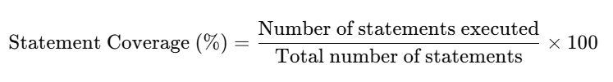
Statement Coverage (%)=Number of statements executedTotal number of statements×100\text{Statement Coverage (\%)} = \frac{\text{Number of statements executed}}{\text{Total number of statements}} \times 100

🔍 Example:
# Source: Chatgpt (GPT-5-Standard) at [8/16/2025]
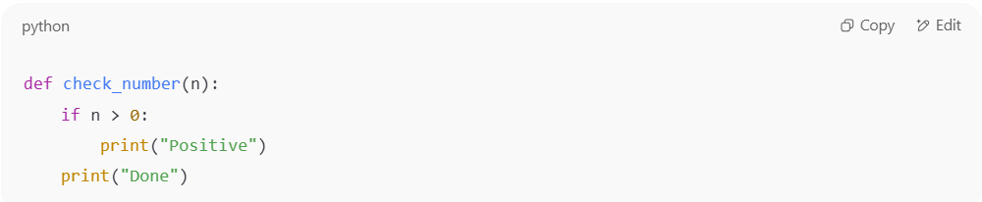
def check_number(n):
if n > 0:
print("Positive")
print("Done")

- Statements:
  - if n > 0:
  - print("Positive")
  - print("Done")
- Test Case 1: n = 5
  - Executes statements 1, 2, 3 → 100% coverage
- Test Case 2: n = -2
  - Executes statements 1, 3 → 2 out of 3 = 66% coverage
👉 To achieve 100% statement coverage, you must test with at least one positive number.

⚖️ Advantages:
# Source: Chatgpt (GPT-5-Standard) at [8/16/2025]
- Simple and easy to apply.
- Ensures all lines of code run at least once.

⚠️ Limitations:
# Source: Chatgpt (GPT-5-Standard) at [8/16/2025]
- Does not guarantee decision logic is fully tested (e.g., true/false conditions).
- May miss logical errors if only one branch of a condition is tested.

✅ In short:
Statement Testing checks whether every statement runs, and Statement Coverage measures how much of the code was actually executed during tests.

